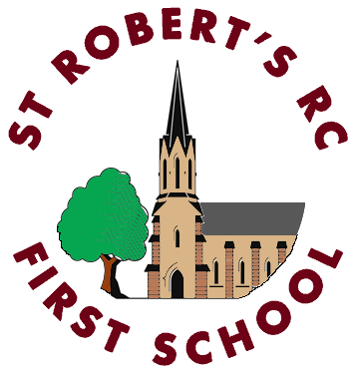
ST ROBERT’S R C FIRST SCHOOL AND NURSERY
SCHOOL UNIFORM POLICY

In order to simplify our uniform and to reduce the cost to parents, we have reduced the number of items of clothing which need to have the St Robert’s logo. We would like to encourage parents to purchase the majority of school uniform from supermarkets/clothing retailers.

We now require children to wear:

. A sweatshirt/cardigan with a logo (currently £9.50/£10 respectively)
. Grey school trousers/shorts/skirt/pinafore (available from supermarkets/clothing retailers)
. White polo shirt (available from supermarkets/clothing retailers)
. Black school shoes

For PE:

. White polo shirt (available from supermarkets/clothing retailers)
. Black joggers/leggings/shorts (available from supermarkets/clothing retailers)
. Black sand shoes/trainers (Please do not buy trainers especially – trainers worn at home are
fine)

Burgundy and white checked dresses can be worn in the Summer if liked (available at supermarkets/clothing retailers), but this is not a requirement. Book bags with or without a strap with the logo will be available, but they are not a requirement (currently £5.40/£6 with strap)

The sweatshirts/cardigans/book bags (pictured below) are available from Emblematic Ltd (you can order online using this link https://emblematic.co.uk/bedlington-store/strfs/). There is also a shop in Bedlington which can be contacted on 01670 820262 to find out opening times if you would like to visit. There is a free collect from school option for orders placed by 1st July for September, otherwise there is a home delivery option at an extra cost.
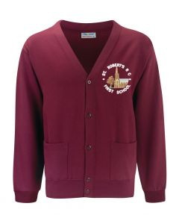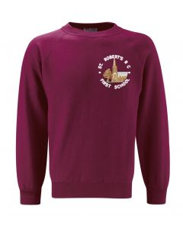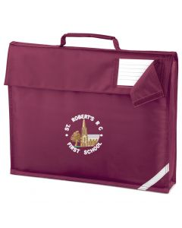
Bag with strap also available
We have a stock of good quality used uniform at school, which is available to all children at no charge. Please contact Mrs Perkins in the Office to see if we have what you need.
This policy was updated on 1st February 2021 and comes into effect on Monday 12th April 2021

